1. 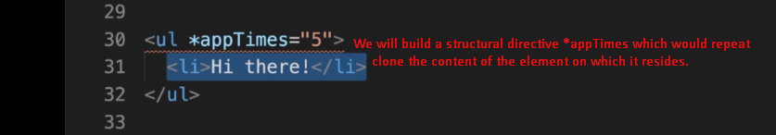
2. 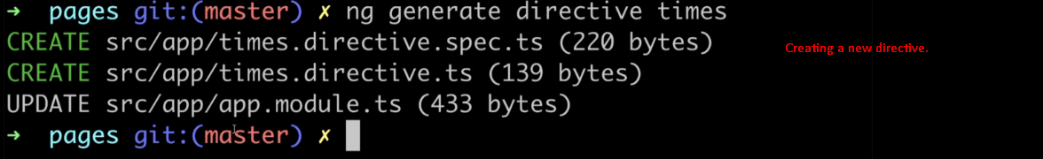
3. 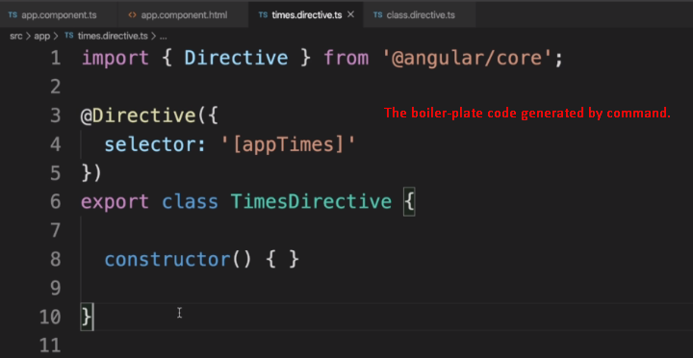
4. 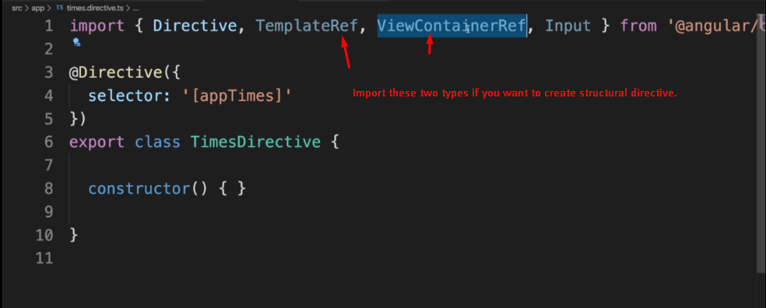
5. 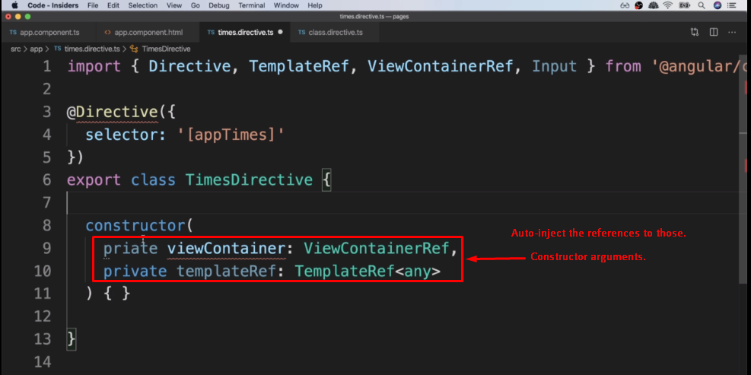
6. **ViewContainerRef**: It is the reference to the element on which we apply the structure directive.
   1. **NOTE**: ElementRef is also the reference to the element on which we apply the directive but there is difference.   
      **Difference**: ViewContainerRef gives a way to easily add/remove sub-elements (means easy way to render some templates inside it)
7. **TemplateRef**: Contains the reference to sub elements of the element to which we apply the structure directive.
8. **Example: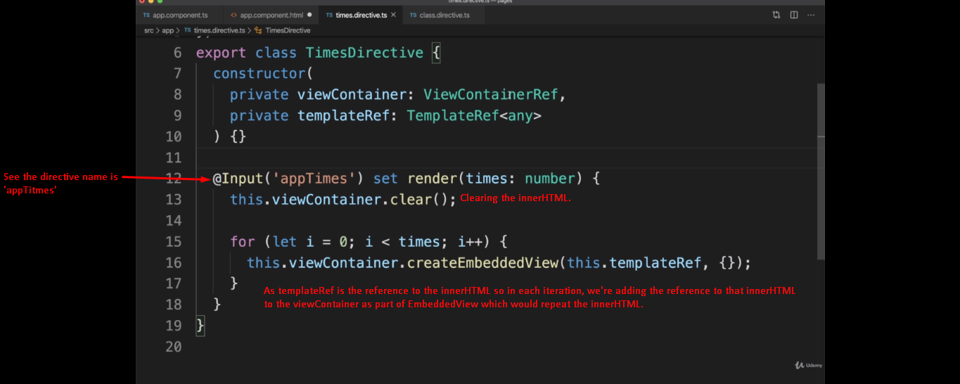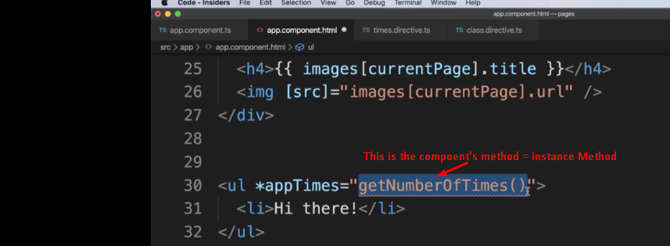If getNumberOfTimes() returns 5.**